

Project title: Employee management system
(Role based privileges)
Group members Name : Malaika Umbreen & Shamama muzaffar
Program: Information technology
Registration number: 22E-UOC/IT-87 | 22E-UOC/IT-69
Course: Database Administration and Management
Date: June-05-2K25

Project title: Employee management system

Objects in Employee management system:
- User
- Role
- Employee
- Department
- Logs
- Report

✅ Identified Objects in Employee Management System:

1. User
Represents system users (login accounts)
Fields: `user_id`, `username`, `password`, `role_id`, `employee_id`, `status`
Related to: `roles`, `employees`

2. Role
Defines user privileges (Admin, HR, Clerk, User)
Fields: `role_id`, `role_name`
Used to assign permissions to `users`

3. Employee
Represents individual employees (HR records)
Fields: `employee_id`, `full_name`, `email`, `phone`, `department_id`, `designation`, `join_date`, `status`
Related to: `departments`, optionally `users`
4. Department
Represents departments in the organization (HR, IT, Finance, etc.)
Fields: `department_id`, `name`

5. Log / Activity Log
Tracks actions taken by users (audit trail)
Fields: `log_id`, `user_id`, `action`, `timestamp`
*Helps in security and monitoring

6. Report (Virtual/Generated)
- Not a physical table (unless stored), but a key object for:

Viewing filtered employee data
Exporting data for Admin insights
Based on queries from: `employees`, `users`, `roles`, `departments`

- Functional requirements for the Employee Management System:
1. User Login
2. Role-Based Access Control
3. Add New Employee
4. Edit Employee Details
5. Delete Employee Record
6. View Employee List
7. Search and Filter Employees
8. Add New User Account
9. Assign Role to User
10. Manage User Accounts
11. Add Department
12. Edit/Delete Department
13. Generate Reports
14. View Dashboard Statistics
15. View Activity Logs
16. Change Password
17. Logout

- Non-functional requirements for the Employee Management System:

1. Security
2. Usability
3. Performance
4. Scalability
5. Reliability
6. Maintainability
7. Availability
8. Data Integrity
9. Portability
10. Backup and Recovery
11. Compatibility
12. Responsiveness
13. Auditability
14. Localization
15. Browser Compatibility

- Use cases for the of the Employee Management:

1. Login
2. View Dashboard
3. Add User
4. Edit User
5. Delete User
6. Assign Role to User
7. Add Employee
8. Edit Employee
9. Delete Employee
10. View Employee List
11. Add Department
12. Edit Department
13. Delete Department
14. Generate Reports
15. View Logs
16. Change Password
17. Logout

- Use case diagram for employee management system:

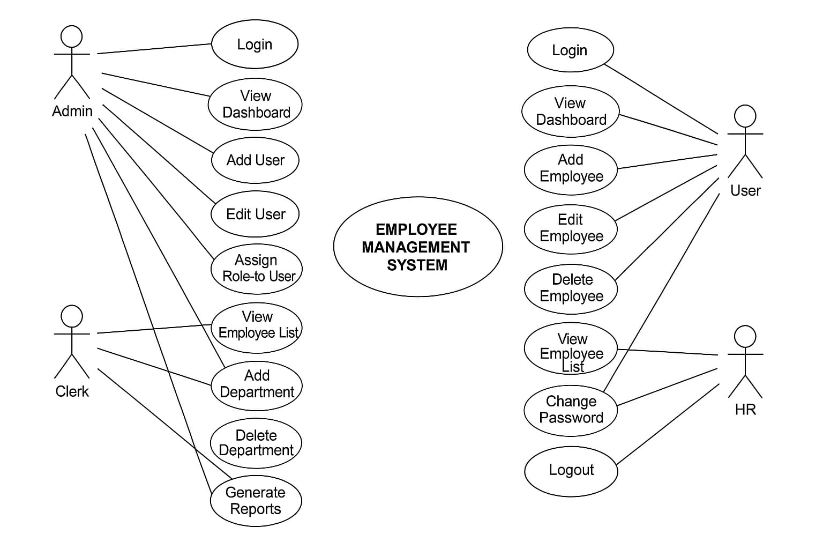
- Class diagram for employee management system:

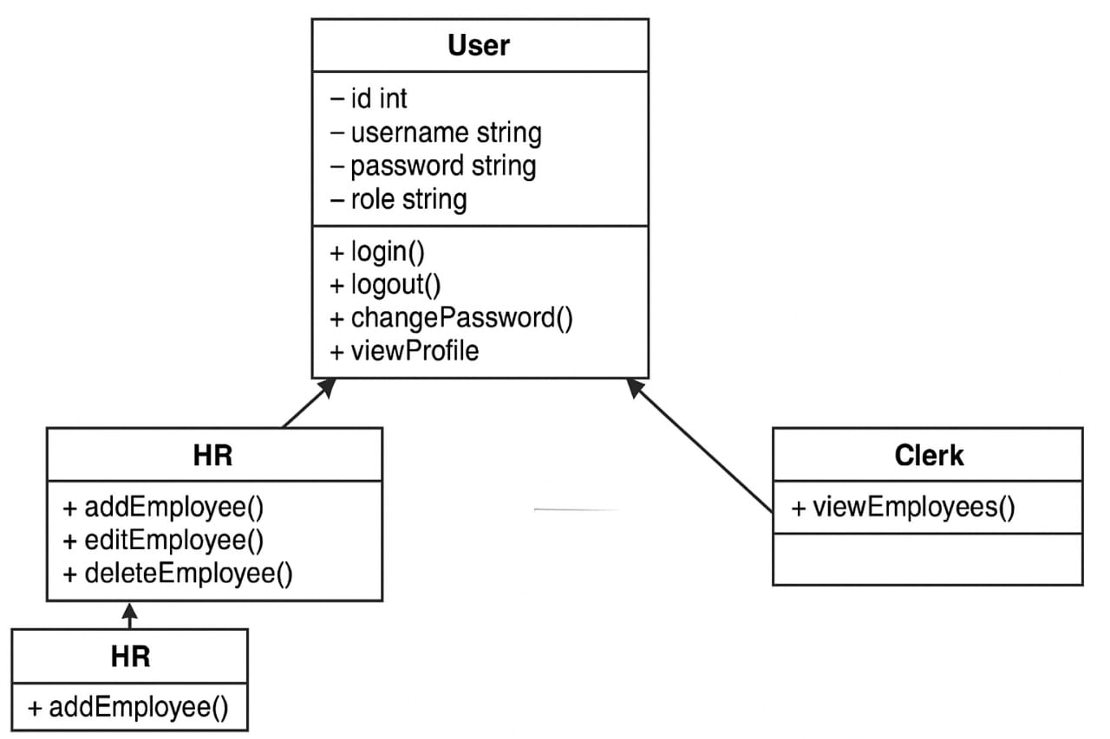

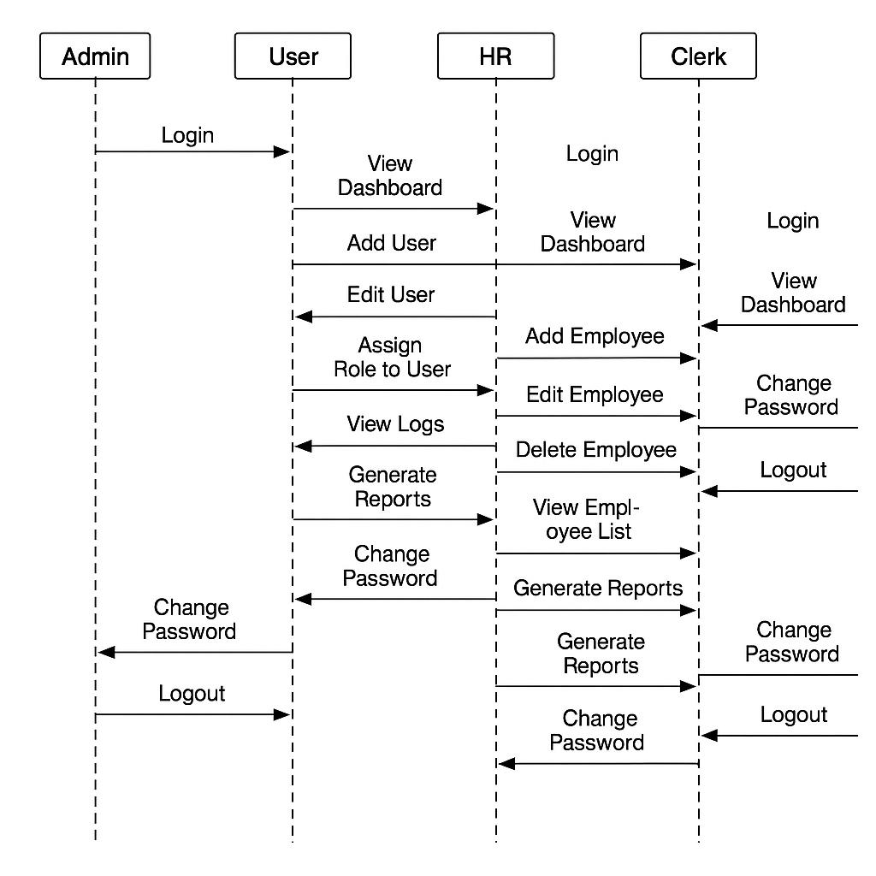
- Sequence diagram for Employee management system

- Activity diagram for Employee management system

